CORS is a protocol that defines some rules for sharing resources from a different origin.

CORS enables you to access a resource from a different origin. It is used to override your browser's default behavior due to SOP(same-origin policy) protocol.

.

So now when your client requests a resource, the response will additionally contain a stamp that tells your browser to allow resource sharing across different origins.

## **Enter CORS**

CORS enables you to access a resource from a different origin. It is used to override your browser's default behavior due to SOP. So now when your client requests a resource, the response will additionally contain a stamp that tells your browser to allow resource sharing across different origins.

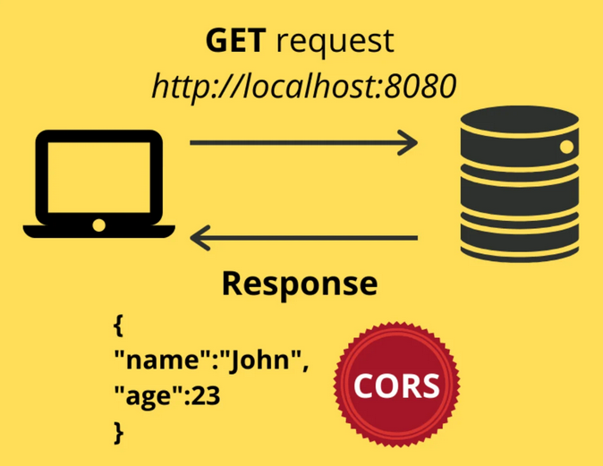

*Client-server request response with CORS enabled.*

Once your browser identifies this stamp, responses for requests from different origins are allowed to pass through. That's precisely what CORS is.